Muscle of the Week - Deltoid
This week we are looking at the Deltoid muscle, which is located above your biceps and triceps at the shoulder. This muscle helps us to raise our upper arm in all directions using different parts of the muscle. There are three different parts which are located at the front (anterior muscle fibers), in the middle (lateral muscle fibers), and in the back (posterior muscle fibers) of the deltoid.

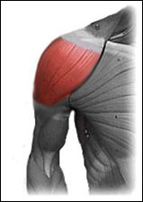

Stretching: Since the deltoid is composed of different muscle fibers with different locations, it can be stretched in a variety of ways. You may find it hard to stretch this muscle without feeling a stretch in other areas. One stretch you can try is for the back of your deltoid where you reach your arm directly across your body keeping your arm straight. Taking your other arm, hug the stretching arm into your body and feel the pull on the back of your deltoid.
Strengthening: When strengthening the Deltoid there are many exercises you can do. The most common deltoid strengthening exercise is a lateral raise. You can do a lateral raise by standing with your arms directly by your side with your arms straight. By slowly raising both arms straight out to your sides in a T shape, you are working your deltoids. You can hold weights, or other things in your hands to help strengthen these muscles using this movement. Another exercise you may do is a front raise. This exercise is done by holding both arms at your side and slowly raising them directly in front of your body keeping your arms straight.

